**Build a Workflow from Scratch with SAP Cloud Platform Workflow Management**DEV163

Exercise 2 | Business Rules  
Archana Shukla / SAP

Table of ContentS

AUTHOR, ACTIVATE AND DEPLOY BUSINESS RULES 3

OVERVIEW 3

CREATE PROJECT 4

CREATE DATA OBJECTS 7

CONFIGURE VALUE HELP IN DATA OBJECT 13

CREATE RULE SERVICE 17

CREATE DECISION TABLE RULE 21

IMPORT DECISION TABLE FROM MICROSOFT EXCEL 29

CREATE RULESET 35

ACTIVATE RULES PROJECT 38

DEPLOY RULE SERVICE 40

Test business Rule 42

OVERVIEW 42

DISCOVER BUSINESS RULES API 43

CONFIGURE TEST ENVIRONMENT 45

INVOKE BUSINESS RULES 47

Summary 49

# 

# AUTHOR, ACTIVATE AND DEPLOY BUSINESS RULES

## OVERVIEW

Estimated time: 45 minutes

The exercise is based on authoring and managing rules for capital expenditure, using SAP Cloud Platform Business Rules. The rule determines the approvers based on investment details.

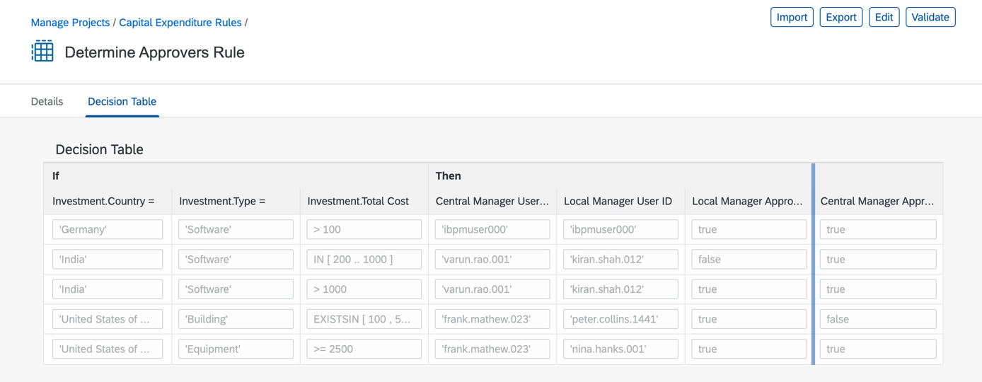

In this exercise, you will learn about different enterprise rule models and how to author them using Manage Rules Application. You will create, configure and activate these business rules models, and learn how to deploy the rule service to cloud for consumption.

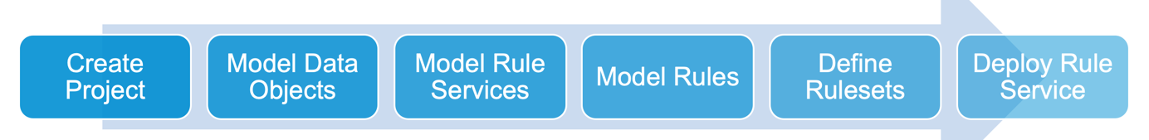

Exercise Description:

In this exercise you will do the following:

* *Create and Configure Project*
* *Create Data Objects*
* *Configure Data Object with Value Help*
* *Create Ruleservice*
* *Create Decision Table*
* *Create Ruleset*
* *Activate Projects and other Models*
* *Deploy Ruleservice in Cloud Platform*

## CREATE PROJECT

| Explanation | Screenshot |
| --- | --- |
| 1. Open Workflow Management Launchpad and click to open **Manage Rule Projects.**     * Login with trial username and passwords |  |
| 1. Click to create a new business rules project. |  |
| 1. Configure Project Name 2. Click on the **Name** text box. |  |
|
| 1. Enter **CAPEX_00** in the **Name** box. |  |
| 1. Enter **Capital Expenditure Rules** in the **Label** box. |  |
| 1. Enter **Capital Expenditure Rules** in the **Label** box. |  |
| 1. Enter **Business rules to determine approvers for new investments in capital expenditure process** in **Description** box. |  |
| 1. Click to select **2.0** as the **Expression Language**. |  |
| 1. Click . |  |
| Your business rules project is created with the needed configurations. |  |

## CREATE DATA OBJECTS

| Explanation | Screenshot |
| --- | --- |
| 1. Click . |  |
| 1. Create **Data Object.** 2. Click . |  |
|
| 1. Enter **Investment** in the **Name** box. |  |
| 1. Enter **Investment** in the **Label** box. |  |
| 1. Enter **Details of the investment** in the **Description** box. |  |
| 1. Click . |  |
| 1. Click . |  |
| 1. Enter **Type** in the **Name** box. |  |
| 1. Enter **Type** in the **Label** box. |  |
| 1. Enter **Type of investment** in the **Description** box. |  |
| 1. Click . |  |
| 1. Repeat the steps to create more data object attributes with following details:      | **Name** | **Label** | **Description** | **Type** | | --- | --- | --- | --- | | Currency | Currency | Currency | String | | Country | Country | Country | String | | TotalCost | Total Cost | Total cost of investment | Number | |  |
| 1. Click . |  |
| 1. Click . |  |
| 1. Click . |  |
| 1. Enter **Approvers** in **Name** box. 2. Enter **Approvers** in **Label** box**.** 3. Enter **Detail of investment approvers** in **Description** box. |  |
| 1. Click . |  |
| 1. Repeat the steps to create Approvers data objectattributes with following details:     Attributes:   | **Name** | **Label** | **Description** | **Type** | | --- | --- | --- | --- | | cm_userid | Central Manager User ID | User ID of central manager | String | | lm_userid | Local Manager User ID | User ID of local manager | String | | lm_required | Local Manager Approval Required | Is approval required from local manager? | Boolean | | cm_required | Central Manager Approval Required | Is approval required from central manager? | Boolean | |  |
| 1. Click . |  |
| 1. Click . |  |
| You have created and configured data objects in business rules project. **Investment** data object will be used as *Input* and **Approver** data object will be used as *Output* in the rule service. These data object & their attributes will be used while modelling rule expressions. |  |

## CONFIGURE VALUE HELP IN DATA OBJECT

| Explanation | Screenshot |
| --- | --- |
| 1. Click to open **Investment** data object. |  |
| 1. Click to add attributes to the data object. |  |
|
| 1. Click to open **Type** attribute. |  |
| 1. Click . |  |
| 1. Click . |  |
| 1. Click . |  |
| 1. Click **Value List**. |  |
| Note: there are two kinds of value help (a) Static and (b) Dynamic. Dynamic *value he*lp can be created with Service **URL Mapping** and **Static** c*an be c*reated with **Value List** type**.** In dynamic value you can connect any backend system and make a service call. In this exercise, you will create static value help where you will manually create value-description pair.   1. Click to create **Value List.** |  |
| 1. Click . |  |
| 1. Click and enter **Software** in **Value** and **Description** box**.** |  |
| 1. Repeat the steps above to add few more values:  | **Value** | **Description** | | --- | --- | | Machinery | Machinery | | Building | Building | | Equipment | Equipment | | Service | Service | |  |
| 1. Click . |  |
| 1. Click . |  |
| 1. Click . |  |
| 1. Click . |  |
| 1. Click . |  |
|  |  |

## CREATE RULE SERVICE

| Explanation | Screenshot |
| --- | --- |
| 1. Click . |  |
| 1. Create **Rule Service****.** 2. Click . |  |
|
| 1. Click to enter **DetermineApprovers** in **Name** box. 2. Click to enter **Determine Approvers** in **Label** box. |  |
| 1. Click to enter **Rule service to determine approvers for new investment** in **Description** box. |  |
| 1. Click . |  |
| 1. Click . |  |
| 1. Click to select **Investment.** |  |
| 1. Click to select **Input**. |  |
| 1. Click . |  |
| 1. Click to select **Approvers**. |  |
| 1. Click **Result**. |  |
| 1. Click . |  |
| 1. Click . |  |
| You have created and configured Rule Service which will be finally deployed once we have configured all the rule entity models. |  |

## CREATE DECISION TABLE RULE

| Explanation | Screenshot |
| --- | --- |
| 1. Click . |  |
| 1. Create Rule 2. Click . |  |
|
| 1. Create Decision Table Rule |  |
| 1. Click to enter **DetermineApproversRule** in **Name** box. |  |
| 1. Click . |  |
| 1. Click and enter **Determine Approvers Rule** in **Label** box. |  |
| 1. Click to enter **Rules to determine approvers for the new investments based on type, country and total cost of the investment** in **Description** box . |  |
| 1. Click . |  |
| 1. Click . |  |
| Note: As you start typing in the condition expression box, you will get context help.   1. From the options, select **Investment >> Country** 2. Click and enter **in** the condition expression box. |  |
| 1. Click . |  |
| 1. Click . |  |
| 1. Click **is** **equal** operator**.** |  |
| 1. Click . |  |
| 1. Repeat the steps above to add few more condition expressions as following:        | **Condition Expression** | **Fixed Operator** | | --- | --- | | Investment.Type | = | | Investment.Total Cost |  | |  |
| 1. Click  to select **Result** data object**.** |  |
| 1. Double-click on **Approvers**. |  |
| Note: When you set access as hidden, the column will not be seen during rule authoring in decision table.   1. Click . |  |
| 1. Click and enter **'Germany'**.     After you have finished typing, press **Enter** key to confirm**.** |  |
| Note: In this expression, you will choose the value from the value help defined for this attribute.   1. Please press **Ctrl+ Space** or press any key**.** |  |
| 1. Expand **Fixed Value** and clickto select value help. |  |
| 1. Click to select **Software** from the value help. |  |
| 1. Click **Enter** to confirm. |  |
| 1. Click to enter **> 100** 2. Press **Enter** toconfirm. |  |
| 1. Similarly, enter the following expression values for the respective result column:  | **Result Column** | **Expression Value** | | --- | --- | | Central Manager User ID | your trial user number | | Local Manager User ID | Your trial user number | | Local Manager Approval Required | true | | Central Manager Approval Required | true | |  |
| 23. Click . |  |
| You have created a decision table-based rule with condition and result columns. You have added a row to the decision table and used in-place context sensitive help to add expressions to the cell values. Now, in next chapter you will use Microsoft Excel to import the data in the decision table. |  |

## IMPORT DECISION TABLE FROM MICROSOFT EXCEL

| Explanation | Screenshot |
| --- | --- |
| 1. Download the **DetermineApproversRule** excel in the same folder in GitHub. 2. Open the excel and update **Project Name,** **Project ID** and **Rule ID** in the available excel sheet as shown in steps below. 3. Update project name with your rules project name like CAPEX_00. |  |
| Now, to update the Project ID and Rule ID you have to go back to the Manage Rule Projects.   1. Navigate back to projects. 2. Click . |  |
|
| 1. Click . |  |
| 1. Click . |  |
| 1. Click . |  |
| 1. Select and press **Ctrl+C** or **Command+C** to copy. |  |
| 1. Paste the copied **Project ID**.   Note: ensure that there are no leading or lagging space while you do the copy & paste. |  |
| 1. Click to open project. |  |
| 1. Click . |  |
| 1. Click . |  |
| 1. Click . |  |
| 1. Click . |  |
| 1. Select and press **Ctrl+C** or **Command+C** to copy. |  |
| 1. Paste the Rule ID   Note: ensure that there are no leading or lagging spaces while you do the copy paste   1. Also, change the *cm_userid* and *lm_userid* to in the first row to your trial username. |  |
| 1. Click to open the rule. |  |
| 1. Click . |  |
| 1. Click to select the excel sheet updated in steps above. |  |
| 1. Click . |  |
| You will have the rows imported in your decision table. |  |
| 1. Click . |  |
| 1. Click . |  |
| 1. Click . |  |

## CREATE RULESET

| Explanation | Screenshot |
| --- | --- |
| 1. Click **Rulesets.** |  | |
| 1. Create Ruleset 2. Click . |  | |
|
| 1. Click to enter **DetermineApproversRuleset** in **Name** box. |  | |
| 1. Click to enter **Determine Approvers Ruleset** in **Label** box. |  | |
| 1. Click to enter **Ruleset that contain rules needed for determining approvers for the new investments** in **Description** box. |  | |
| 1. Click to select **DetermineApprovers** as **Rule Service**. |  | |
| 1. Click . |  | |
| 1. Click . |  | |
| 1. Click . |  | |
| 1. Click to select . |  | |
| 1. Click . |  | |
| 1. Click . |  | |
| You have created the ruleset, associated it with rule service and added the rule. Ruleset is a collection of rules of similar output. |  | |

## ACTIVATE RULES PROJECT

| Explanation | Screenshot |
| --- | --- |
| Before you deploy the rule service, all the rule entity models have to be in activated state. In this chapter, you will go through all the models to ensure that they are activated.   1. Click . |  |
| 1. Click . |  |
|
| 1. Click . |  |
| 1. Click . |  |
| 1. Check if all the data objects are in **Active** state. |  |
| 1. Check if all the rule services are in **Active** state. |  |
| 1. Check if all rulesets are in **Active** state. |  |
| 1. Check if all rules are in **Active** state. |  |

## DEPLOY RULE SERVICE

| Explanation | Screenshot |
| --- | --- |
| 1. Click . |  |
| 1. Deploy Rule Service 2. Click . |  |
|
| 1. Click **SAP Cloud Platform** todeploy the rule service. |  |
| 1. After the ruleset is deployed successfully, you will see the message. Now, the rule service can be consumed via the REST APIs |  |

# 

# Test business Rule

## OVERVIEW

Estimated time: 15 minutes

In the following exercise you will learn the basics of testing business rules invocation from APIs available in SAP API Business Hub.

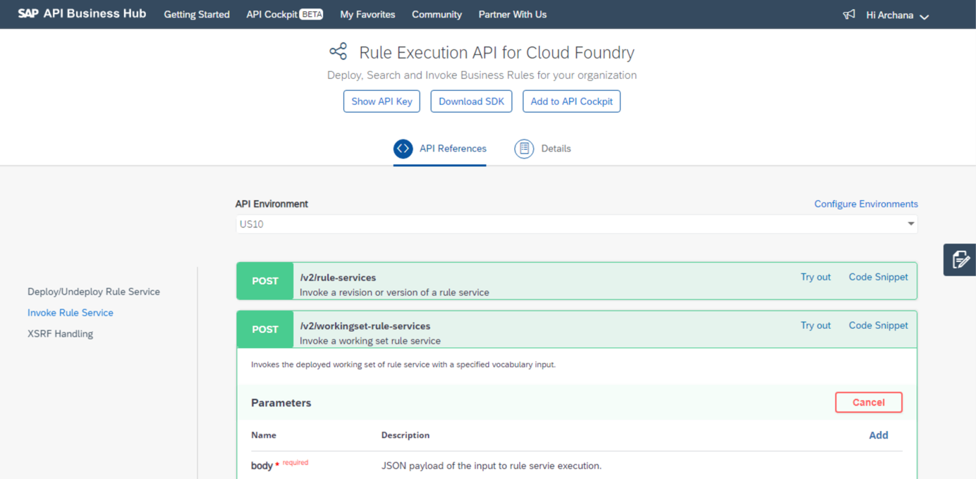

Exercise Description

In this exercise you will do the following:

* Discover Business Rules API in SAP API Business Hub
* Configure Cloud Foundry Test Environment
* Invoke Business Rules

## DISCOVER BUSINESS RULES API

| Explanation | Screenshot |
| --- | --- |
| 1. Open **API Business Hub** using this URL: <https://api.sap.com> 2. Click . 3. using your S or P user ID |  |
| 1. Search Business Rules API 2. In **Search** box, enter **business rule** and press **Enter key** to search. |  |
|
| 1. Click  API Package. |  |
| 1. Enter **execution** in the  box. |  |
| 1. Click  to search the execution APIs.   Note: Business Rules have two set of APIs: Authoring and Execution. You will also notice two set of versions v1 and v2. Version v1 is currently deprecated and will soon be unsupported. |  |
| 1. Click on **Rule Execution API for Cloud Foundry** version v2 APIs. |  |
|  |  |

## CONFIGURE TEST ENVIRONMENT

| Explanation | Screenshot |
| --- | --- |
| 1. Click . |  |
| 1. Set configuration properties   Enter these details in the following configuration properties from the business rules service key:   * **Display Name for Environments**: US10 * **runtimeurl:**   + *bpmruleruntime.cfapps.us10.hana.ondemand.com*   OR   * + *bpmruleruntime.cfapps.eu10.hana.ondemand.com*      - depending upon the region in which you have created the trial account.   Press **Tab** to move to next property. |  |
|
| 1. Enter these details in the following configuration properties:   **Client Id:** sb-clone-12628bc9-e039-46ed-a77d-342fe0f5d84b!b5326|bpmrulebroker!b2018  **Secret:** EHa02gKesOCyfEhjgg1SIT6A3SA=   1. Please press **Tab**. |  |
| 1. Enter the following as token url and other standard properties:   **tokenurl** : sapintelligentbpm-us10.authentication.us10.hana.ondemand.com  Note: the details of runtimeurl, clientId, secret and token URL is collected from business-rules service instance in cloud cockpit.   1. Click  **for Apply this environment to all APIs**. 2. Click  for **Save this environment for future sessions**. |  |
| 1. Click . |  |
| 1. Click . |  |
| 1. From the left options, Click . |  |
| There are 2 types of invocation APIs. First one is to invoke versioned rules and second one is to invoke non-versioned or working set rule. |  |

## INVOKE BUSINESS RULES

| Explanation | Screenshot |
| --- | --- |
| 1. Click  of **/v2/working-set-rule-services** API. |  |
| 1. Execute Working Set API 2. Click . |  |
|
| 1. Press **Tab** until you reach the body section. 2. In the **body** section**, Copy & Paste** this text:   {   "RuleServiceId": "ba2229ca79874fe381ced8a4ee6dad21",         "Vocabulary": [             {                 "Investment": {                     "Currency": "EUR",                     "Country": "Germany",                     "Type": "Software",                     "TotalCost": 10000                 }             }         ]     }  Replace the **RuleServiceId** with rule service id of your rules project. |  |
| 1. Click **Execute**. |  |
|  |  |

# Summary

You have completed the exercise!

You are now able to:

* Create & Activate Project, Data Object, Ruleservice, Ruleset and Rules
* Configure Value Help in Data Object
* Use Microsoft Excel Import/Export functionality in Decision Table
* Deploy Ruleservice
* Discover Business Rules API in API Business Hub
* Configure Test Environment for Cloud Foundry
* Execute Business Rules Execution API

# 